

DEPARTMENT OF INFORMATION TECHNOLOGY
SCHOOL OF COMPUTING AND INFORMATICS

LOGBOOK: MOBILE APPLICATION DEVELOPMENT
UNIT CODE: BIT4107
NAME: YUSUF ANEMBA
REGNO: BIT/2020/90745
PROJECT NAME: MASENO WISDOM HOSTELS MOBILE APPLICATION

- Toolchain Installation: Confirmed configuration parameters for Visual Studio Code, Node.js packages, and mobile rendering targets.
- Project Directory Setup: Formed the root workspace and structural source files using the Expo terminal CLI.
- Environment Troubleshooting: Debugged path context boundaries within the Windows command terminal to safely run active packaging commands inside the localized workspace.

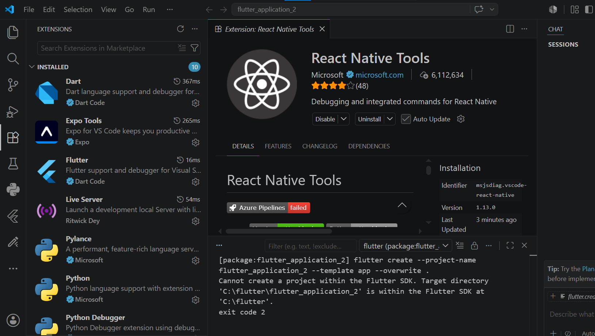Figure 1.1 Successful installation of extensions in vs code

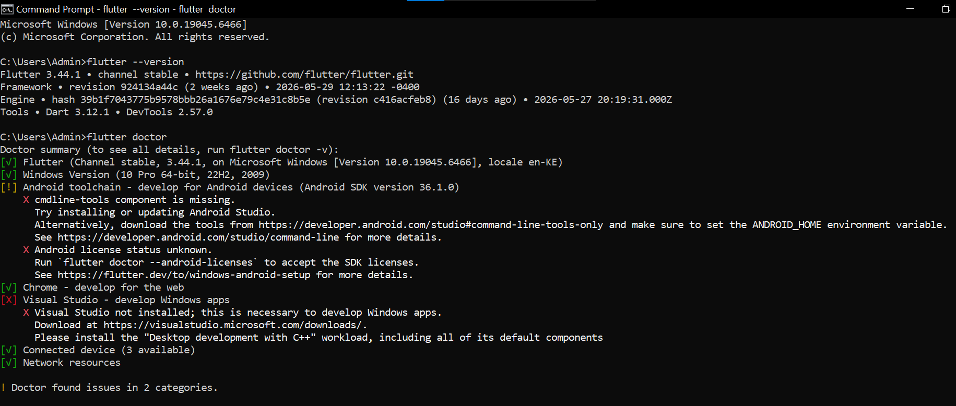
Figure 1.2 Running flutter doctor for the first time
I ran into several issues, one being I had not installed the SDK manager and the other one I had not downloaded and set up the visual studio for windows apps development.

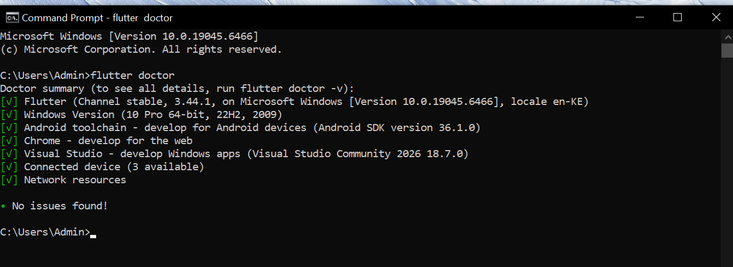
Figure 1.3 running flutter doctor successfully with no issues found.
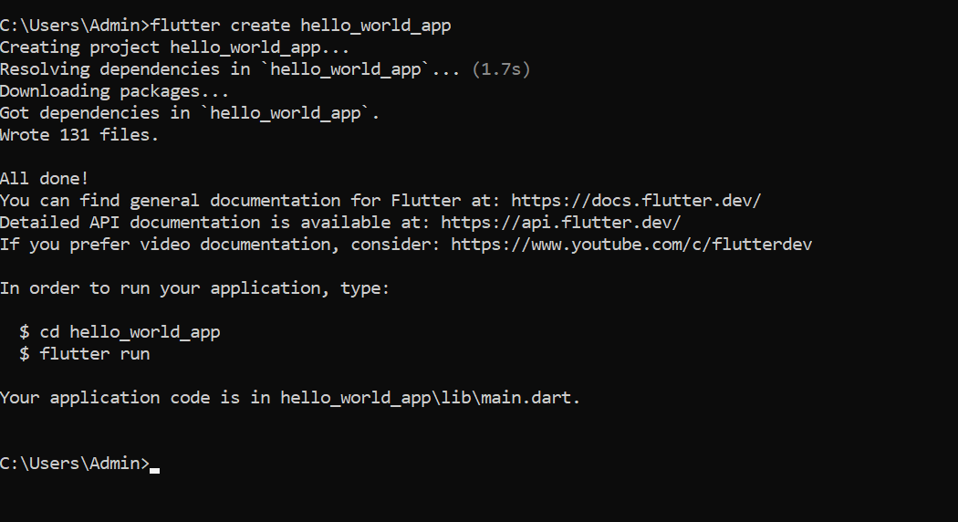
Figure 1.4 creating the hello world mobile app from the command prompt.

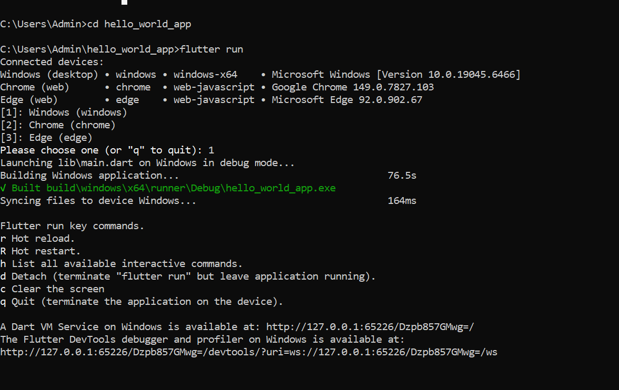
Figure 1.5 ran flutter to start creating the app

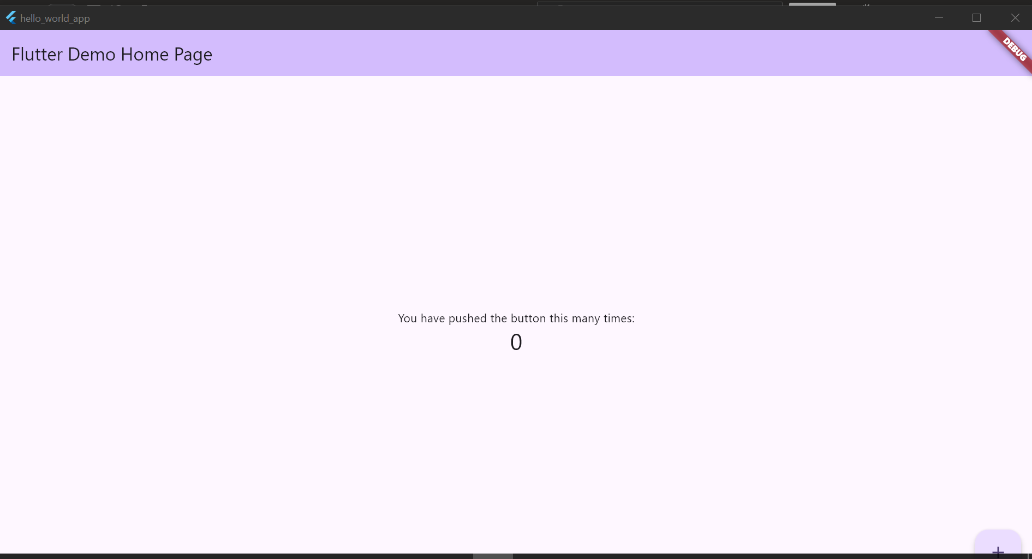
Figure 1.6 demo app created and running
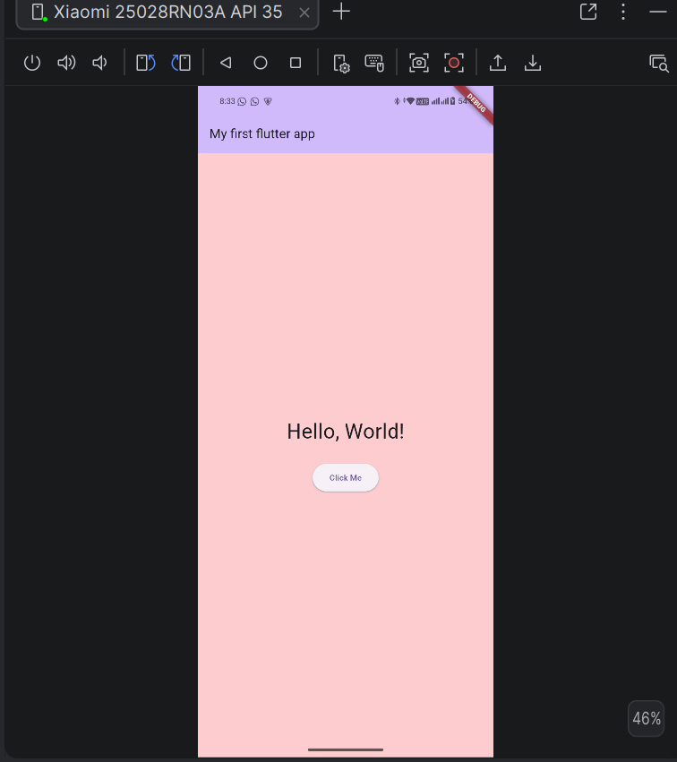
Figure 1.7 hello world mobile app
This is my first hello world app with a button.
Tools used
- Flutter
- Java JDK 17
- Andriod studio
- Dart
- CMD

